CAIRNGRYFFE PARISH CHURCH NEWSLETTER
November 2022

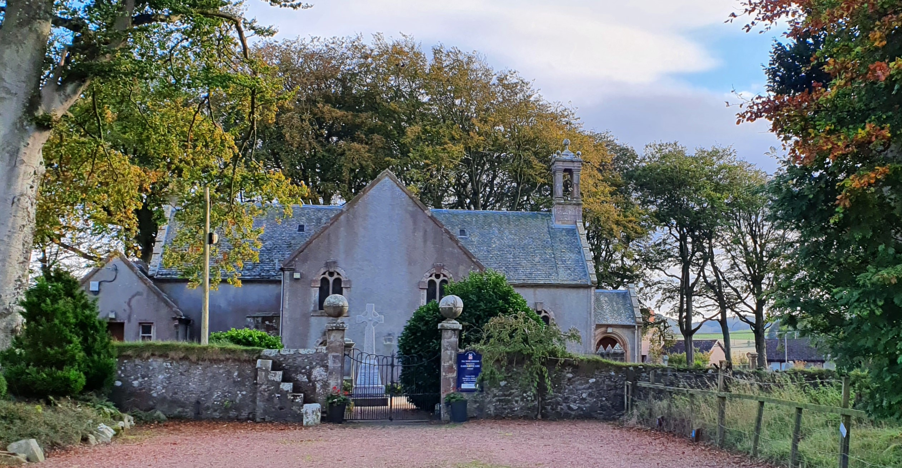

Members of the congregation are warmly invited to our
Celebration of Communion
On Sunday 6th November 2022 at 11 am.

Cairngryffe Parish Church: one of the Tinto Parishes
Charity Number – SC 017001

From our Interim Moderator

Dear members and friends in Cairngryffe Church,

On his death bed, John Wesley reportedly spoke these last words: “The best of all is, God is with us.” Through thick and thin, celebration and disaster, wellness and suffering, indeed, in our living and dying: God is with us. This sums up the promise of Christ Jesus for us in this life and the life to come. The impact of the pandemic is piling fresh pressures on our National Health Service, and causing genuinely serious worries about the coming winter. In addition, while, the Ukraine/Russia conflict rumbles on with death and destruction on every side; resulting in global shortages of energy supply and basic foodstuffs; we find ourselves taking shelter in the knowledge of God’s love. We are not guaranteed riches or a life free of suffering or pain, only a life filled with the love, compassion, and caring of Christ accompanied with the mandate to live a life filled with love, compassion and caring for our neighbour.

As you may know, at recent General Assemblies the whole church has been instructed to begin to draw up plans which will look at the future shape and number of ministries. The Presbytery of Forth Valley and Clydesdale, like other Presbyteries across the country, is on the process to ensure that the church is properly equipped to deliver the Good News of Jesus Christ in a dynamic and sustainable way. Across the country the whole Church of Scotland is facing similar challenges in planning, and the process is not an easy or straightforward one, but the ultimate goal, whatever Plan is finally agreed, is to ensure that the good work of the Church continues. In this sensitive and unsettling time, please pray for our congregation, our neighbouring congregations in the Presbytery, and the whole Church of Scotland. It will be together that we will, through God, discern a way forward.

Our God never fails, he is always walking beside us and he knows what the future holds. God has a future planned out for us, our congregation and our communities. Our purpose is not to recreate yesterday but to make today filled with the new workings of God. We can together sing: ‘‘Because He lives, I can face tomorrow. Because He lives, all fear is gone. Because I know He holds the future; and life is worth the living, just because He lives.’’

God bless you!

Rev. Dr. Elijah Obinna
Interim Moderator

INFORMATION
Interim Moderator: Rev Dr Elijah Obinna, Minister of St John’s Church, Carluke
Tel: 01555752389
Session Clerk: Dr Rosmairi Galloway, Pepperknowes, Carmichael, Biggar ML12 6PH
Mobile: 07733446567
Prayer Promoter: Liz Hiddleston Tel; 018999 221664
Visit Our Website: www.cairngryffekirk.org.uk Webmaster: Jim Watt
News from the Session
How quickly the seasons change, as I write this, we are about to celebrate Harvest Thanksgiving and are looking ahead to Christmas.
This year we are going to have a new venture for us, on Saturday 3rd December at 2pm we will have a Carols and Christingles service, to help prepare us for the Advent and Christmas Season. This will be an all ages, family service where we can have the fun of making a Christingle and hearing about the Christmas Story. Please come along. There will be time for fellowship and refreshments after the service.
At Easter Time we gave each pupil at Carmichael Primary School an Easter Gift of a booklet about Easter, a packet of wildflower seeds, a pencil and a small Easter Egg. Angela also distributed Easter Eggs to the local Mother and Toddler Group, for the little ones and their older brothers and sisters. We have received a beautiful handmade Thank You card from the school, signed by every pupil. We hope to be able to make a small Christmas gift to each school pupil from the church.
The Rev George Shand will be leading our November Communion Service. At the moment arrangements for Communion are; your individual filled communion glass will be in the cup holder in your pew, and a small bag with your bread will be on the pew shelf when you arrive. These elements will be blessed by the minister during the service so that you can take communion. Cairngryffe Sunday services from now till the end of the year are all at 11am, our Interim Moderator has arranged Pulpit Supply; we welcome, Rev Elizabeth Clelland, Rev George Shand and Alan Grant when they visit us and take our services, every second week our own Congregational Worship Team will lead worship.
In the New Year 2023 our Sunday Worship for January until the end of March should be at 11am.
Although we do not have our own minister our church is always available for family life events: baptisms, weddings and funerals; as Interim Moderator Dr Obinna ensures that a minister is available when we need one.
Our Session has spent a considerable amount of time discussing Presbytery’s Mission Planning Process, responding to questionnaires and attending meetings, see Presbytery Report for an update about the process. Denham MacDougall continues in his work as Intermin Moderator at Douglas Valley and Jim Watt is also very busy as Co- Moderator of Forth Valley and Clydesdale Presbytery.
We value your continued support of our church. People contribute to our church in many ways; attending on Sundays, giving of their time, talents and money. It is more than ever important that we all continue to support our local church at this difficult time when we readjust and recover from the impact of the Covid Crisis, and face our time as a Charge without a Minister, the readjustments within the Church of Scotland and continue our Christian Witness in our local area. Let us hope that we are able to rebuild and renew our church family and community in the days and months ahead.
Rosmairi J Galloway
Session Clerk.
Rev Dr Graham Houston BSc, BD, MTh, PhD
It was with great sadness that we learnt of the death of our retired minister the Rev Dr Graham Houston on 4th July 2022. Graham retired from the linked charge of Cairngryffe with Symington at the end of 2010. His health declined over the years and he was devotedly looked after and nursed by his wife Irene.
After attending Hutchison Boys Grammar School in Glasgow, Graham studied Architecture at Strathclyde University, while there he became involved in student Christian activities and was called to the ministry. He studied theology at Aberdeen University. He served as a Church of Scotland Assistant Minister in Edinburgh where he met his wife, Irene. He was ordained in 1978.
Irene and Graham married just as Graham was called to his first charge in Helmsdale. He was subsequently parish minister at Letham St Marks in Perth, before becoming chaplain at Herriot Watt University. Graham briefly served as Director of the National Bible Society of Scotland.
Graham was inducted to the linked charged of Cairngryffe and Symington in 2001 his ministry here, was interrupted by periods of ill health.
During his career Graham also wrote three theology books:
Prophecy Now (1989), Virtual Morality (1998) and Leading by Example: Peter’s Way for the Church Today (2008), these books are still recognized textbooks for students of theology.
Graham’s funeral took place at Cairngryffe on Saturday 16th of July. The service was conducted by fellow ministers who had become lifelong friends and members of the family.
We extend our sympathy to Graham’s wife Irene, his children Rachel, Rhoda and Stephen and their families.
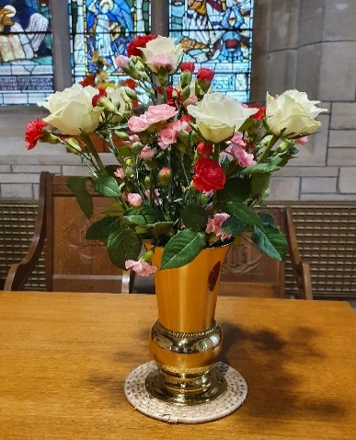
Donations
During the pandemic we have encouraged giving by direct debit, or sending a cheque to our treasurer. An open plate is available at the church entrance for free will offering.
Gift Aid enables us to claim back Tax, this boosts our income considerably.
However, as a charity, we should have Gift Aid Declarations which have been signed in the last 2 years. Most of us have not signed a declaration form recently. Gift Aid Declaration Forms are available from your Elder, the Session Clerk or Treasurer. Completed forms should be returned to them.

Carmichael Primary School
Are holding a Community Café at 1.30pm on Thursday 10th of November 2022 in Carmichael Village Hall in aid of Macmillan Cancer Support.
Please support this worthwhile event.

Life and Work
The monthly magazine of the Church of Scotland increases to £3.50 a month in January 2023
Session Meeting
Monday 7th November 2023 at 7.30pm in the church.
Guild
Cairngryffe Guild has a joint meeting with Symington Guild in Symington Church on Thursday 17th November at 2pm.
The Guild also meets on Wednesday 14th December in Thankerton Bowling Club at 2pm.
For further information please contact the Guild Secretary Elizabeth Forbes on 01555 640018.

Ever Young
The Everyoung meet in Thankerton Bowling Club on the 2nd and 4th Thursdays of the month at 2pm with a speaker, tea and a blether.
27th October Frank Morrison (accordion) and Alan McCollough (guitar &vocals)
10th November Charlie with a slide show of Old Carmichael photos
24th November- Squeeze & Teeze (John Morgan, accordian and his wife Muriel, vocals) from Slamannan and a tea by CRUK Biggar £5 a ticket.
December meeting possibly a Christmas Lunch
Contact Charlie Todd for further details on 01899 308327

Reflection for Autumn
While the earth remaineth, seedtime and harvest, and cold and heat, and summer and winter, and day and night shall not cease. Genesis 8:22
As we approach Autumn we celebrate Harvest Thanksgiving, to give thanks for the bounty of the land. The Bible was written at a time when people lived closer to the land and were in tune with the seasons. From the earliest days of the Old Testament, God made humans stewards of the land and the planet. There are many references to farming and stewardship of the land throughout the Bible. The parables of the Sower and the Lost Sheep are just a couple of examples.
Our own church is a very rural church, where our ancestors and predecessors have worked the land and worshipped here over the centuries.
Our church has been beautified by the addition of many stained-glass windows over the years. The most recent was gifted in 1998 by Mrs and Mrs James Warnock of Sandilands and Watchknowe Farms in thanksgiving for their fifty years both in Sandilands and in the life of the church here. Crear MacCartney of Wiston was chosen as the designer and artist of the window. Crear MacCartney was a wise choice; he had a vast knowledge of the Bible, of church history, religious symbolism, heraldry, butterflies etc. and ensured that his windows could tell a story with many strands interwoven.
The window depicts local scenes, in the Sandilands scene, two Clydesdale horses work together in harness, pulling a plough. The breeding of the Clydesdale horse in this locality and the invention of the swing plough by James Small, a Berwickshire blacksmith both took place in the late 18th century, these two advances in agriculture transformed agriculture and harvest yields.
Carmichael Mill dates back to the Middle Ages, bearing evidence of the long heritage of farming in the community. Seedtime and harvest, mountain and river and the changing seasons have sustained and inspired countless generations with a love of Christ, whose great symbol, the vine binds the design together, “I am the Vine, ye are the branches” John 15:5.
The rainbow contains the colours of the spectrum, all have their origin in the three primary colours; red, blue and yellow. Through this is proclaimed the infinite abundance of all Creation. The spectrum is at the heart of the design; its colours shower a Benediction into the kirk, a Blessing from the Father, Son and Holy Spirit (the three interlinked circles of colour), the promise of Hope for the future.
These colours reflect into the kirk and at different times of day and on different days the reflection is picked up on different parts of the kirk. However, there is a sure and certain pattern annually where the reflection is seen, a reflection on the sureness and certainty of God’s love.
Seedtime and harvest are so closely linked; a good seedtime helps to grow a good harvest and a good harvest lays the foundation for the next seedtime.
Robert Louis Stevenson said that perhaps we should not just be judged by our harvests but by the seeds we sow.
See the reflections of the colours of the window and reflect on many seedtimes and harvests.

Presbytery report for Autumn Focus 2022

The Presbytery Mission Planning team (MPT) have been working very hard over most of this year and recently produced proposals for the future shape of the Church. As far as those for our local area were concerned they were generally felt to be impractical. Your Kirk session have prepared an alternative proposal which we feel would be more workable.
It was intended that the MPT would be stood down and replaced at the 4th October meeting, as three of their number had already had to resign for personal reasons, however, due to some disrespectful communications they had received, the entire team felt they had no choice but to resign. Names to form a new group, to be called the Mission Plan Action Group (MPAG) are to be brought to a special on-line meeting on 27th October for approval. The information collected by the MPT will be passed to the new group. Permission is being sought from Central Offices for an extension, to early summer 2023, to be the time by which the Mission Plan has to be submitted. Recognising the enormity of the task the Faith Nurture Forum have appointed two Interim Ministers to the Presbytery on a short term basis to work with the MPAG. It has also been agreed that a Mission Plan Implementation Officer be appointed for a period of 18 months and the job description for this is on the Church of Scotland website.
Rev Paul Grant has demitted from Law Parish Church to take up a post as Chaplain at Glasgow Royal Infirmary, Rev Lorna MacDougall (Overtown) being appointed as Interim Moderator.
The retirement, at the end of October, of Rev Iain Cunningham from Carluke: Kirkton was recorded at the October meeting and a tribute was given to his long ministry there of 34 years. Iain’s name may be familiar to some of you as the writer of several hymns in our current Hymnary and he served as our Interim Moderator in the past.
Mrs Deborah Chesnutt has been appointed chaplain at Braehead House and her Ordination will take place in Lanark: Greyfriars Church on Tuesday 25th October at 7:00pm.
Jim Watt (Presbytery Elder)
From Our Community Outreach Worker
Hello everyone,
What a summer we have had. It has been lovely to see everything finally starting to open up and feel a little more familiar again. One of the nicest opportunities has been receiving an invitation to visit Carmichael Primary a few weeks ago with the promise of being in there a little more. The school is holding a community café in the afternoon of Thursday 10th of November, so I hope some of you can come along.
Our farming chaplaincy at the mart has been coming along nicely over the summer as I am becoming a familiar face. I took the opportunity to get to a few agricultural shows this summer too. It is great to catch up with folks out with Lanark market and opened up some other possible opportunities which may come into fruition over the coming months.
The Anna Chaplaincy project and the farming chaplaincy are coming together in a wee project about field names. I would love to hear from any of our famers, current and retired, who would be willing to tell me about the names they have called their fields. Eventually I hope to be able to produce a wee book, similar to the one published in Kirkcudbrightshire which has inspired this project.
Talking of the Anna Chaplaincy we are in the process of piloting “Church in a Bag” for some folks in our community who aren’t as able to come along on a Sunday. The bags will vary each time depending on resources available but will include a sheet with a personal act of worship and some form of activity. If you are interested in being included in being a regular beneficiary of this project, please let your district elder or Rosmairi know. Also, if you would like to help contribute to this project, please let me know.

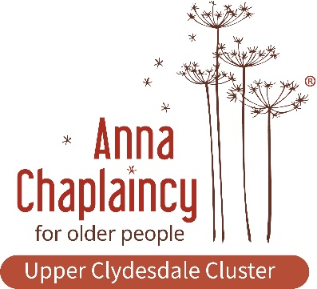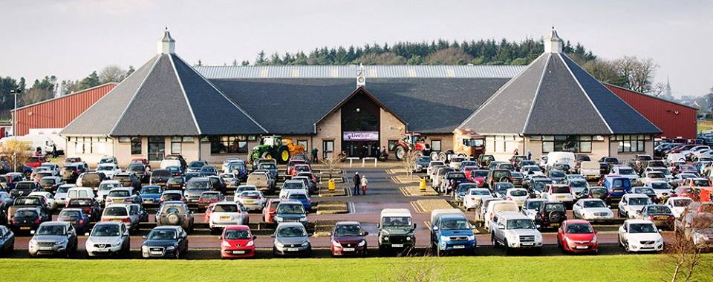
Church Flowers
Church flowers have become an established tradition over the past century in the Church of Scotland. The flowers are either gifted for a particular Sunday on a Flower Calendar or gifts of money given specifically towards the Flower Fund, the money is then used to buy flowers to brighten up our church for Sunday worship. After the service most Sundays the flowers are then gifted to a church member or someone in the community. Just a small gift and reminder that the church family is thinking about them when they have been ill, had a bereavement, celebrate a birthday or they are no longer able to attend church.
If you would like to book a Sunday in our Flower Calendar or contribute to the Flower Fund please contact the Session Clerk.
Kentigern Way Pilgrim Route
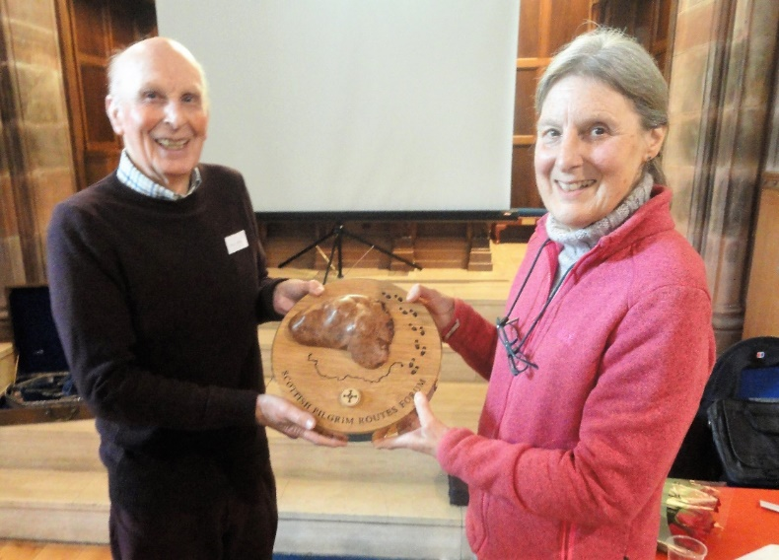
Bill Jack receiving the John Henderson Award from the Very Rev Dr Sheilagh Kesting

Kentigern Way Pilgrim Route was established last year. Bill Jack one of the founders of the route has been awarded the first annual John Henderson Award from the Trustees of the Scottish Pilgrim Routes Trust for his outstanding contribution in developing the Kentigern Way.
The Kentigern Way uses established walking routes in Annandale, Tweedale and Clydesdale and offers Pilgrims a walking route from Hoddam just north of Annan to Glasgow that represents routes that St Kentigern would have used as he evangelized this area in the early 600’s. We are one of the churches on the route and Pilgrims are welcome to visit us.
St Kentigern is also well known as St Mungo and has a close association with Glasgow and the West of Scotland, the Glasgow coat of arms commemorates the miracles of Kentigern or Mungo.
Here is the bird that never flew
Here is the tree that never grew
Here is the bell that never rang
Here is the fish that never swam

For further information about the Kentigern Way https://kentigernway.com

TINTO PARISHES WORSHIP
NOVEMBER – DECEMBER 2022
Sunday Worship
Date | Cairngryffe | Libberton &Quothquan | Symington
 | 11.00am | 9.30am | 11.00am
06 11 2022 | George Shand | George Shand | WG- Bill Buchan
13 11 2022 | WG | Bill Buchan | Bill Buchan
20 11 2022 | Alan Grant | Alan Grant | WG
27 11 2022 | WG | Alan Grant | Alan Grant
04 12 2022 | George Shand | George Shand | WG
11 12 2022 | WG | Elizabeth Clelland | Elizabeth Clelland
18 12 2022 | Alan Grant | Alan Grant | WG
25 12 2022 | Christmas Day 10.30am at Libberton George Shand
01 01 2023 | New Year’s Day 11AM at Cairngryffe Bill Buchan

JANUARY 2023
Sunday Service Times
Cairngryffe at 11.00am
Libberton & Quothquan at 11.00am
Symington at 9.30am

Advent and Christmas Services at Cairngryffe
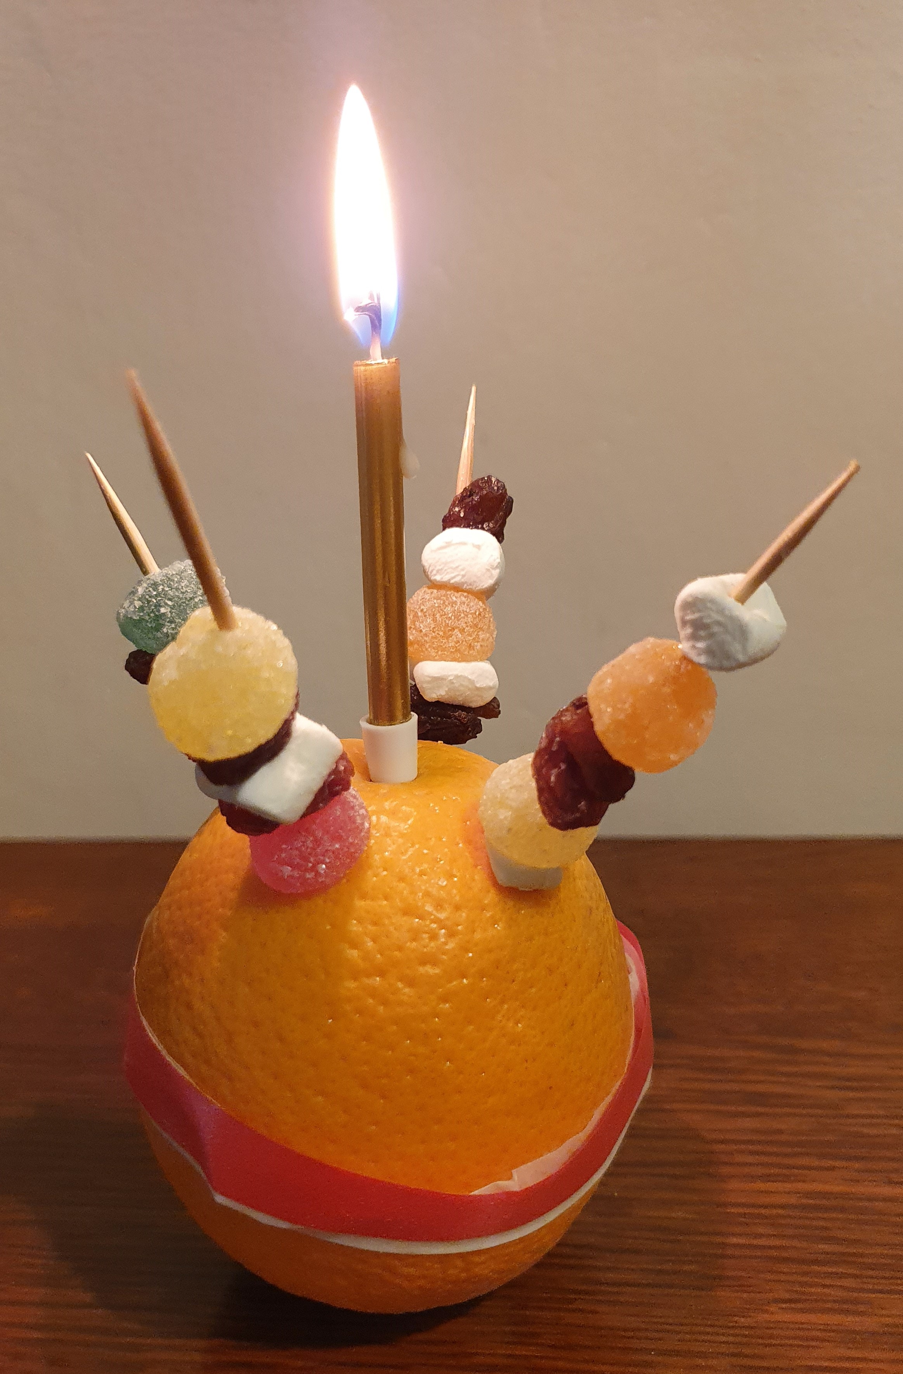

Saturday 3rd December 2-3pm Christingle Service
Carols and Christingles, a short service to help us prepare for Christmas.
Refreshments after the service. This is an event for all ages and all the family.

Saturday 24th December 2022
Watchnight Service, gather in the church from 11.00pm, service starts at 11.30pm.

